

**CAPSTONE PROJECT II**

CMU-SE 451

**PRODUCT BACKLOG**

Version 1.1

Date: May 11th, 2021

**FACIAL IDENTIFICATION MATCHING**

**Submitted by**

**Tran, Tran Thi Thuy**

**Han, Hoang Gia Bao**

**Trang, Tran Thi Huyen**

**Kieu, Dinh Thi Van**

**Vi, Pham Ha**

**Approved by**

**Trang, Nguyen Thi Bao M.Sc.**

Proposal Review Panel Representative:

Name Signature Date

Capstone Project 2- Mentor:

Name Signature Date

|  |  |  |  |
| --- | --- | --- | --- |
| **PROJECT INFORMATION** | | | |
| **Project acronym** | FIM System | | |
| **Project title** | Facial Identification Matching web application | | |
| **Start date** | March 1st, 2021 | **End Date** | Jun 2th, 2021 |
| **Lead institution** | International School, Duy Tan University | | |
| **Project mentor** | Trang, Nguyen Thi Bao M. Sc  Email: nguyenthibaotrang@gmail.com  Phone: 0915 774 711 | | |
| **Product owner & Contact Detail** | Trang, Nguyen Thi Bao M. Sc  Email: nguyenthibaotrang@gmail.com  Phone: 0915 774 711 | | |
| **Partner organization** | Duy Tan University | | |
| **Scrum Master** | Tran, Tran Thi Thuy | tranthuy1944@gmail.com | 090 505 7851 |
| **Team members** | Han, Hoang Gia Bao | baohanhoang2606@gmail.com | 093 563 8848 |
| Trang, Tran Thi Huyen | tranthihuyentrang7251@gmail.com | 037 495 7251 |
| Kieu, Dinh Thi Van | dinhvankieu199@gmail.com | 089 985 2540 |
| Vi, Pham Ha | Phamhavi255@gmail.com | 032 657 7627 |

|  |  |  |  |
| --- | --- | --- | --- |
| **PRODUCT BACKLOG DOCUMENT** | | | |
| **Document Title** | Product Backlog Document | | |
| **Author(s)** | HIT LIST Team | | |
| **Role** |  | | |
| **Date** | May 11th, 2021 | **File name:** | [FIM]ProductBacklog_ver1.1 |
| **URL** |  | | |
| **Access** | Project and CMU Program | | |

|  |  |  |  |
| --- | --- | --- | --- |
| **REVISION HISTORY** | | | |
| **Version** | **Person(s)** | **Date** | **Description** |
| **1.0** | All members | March 5th, 2021 | Create document |
| **1.1** | All members | May 11th, 2021 | Update sprint 4 in section 2.3 |

|  |  |  |  |
| --- | --- | --- | --- |
| **SIGNATURE**  **Document Approvals:** The following signatures are required for approval of this document. | | | |
| **Mentor & Product owner** | Trang, Nguyen Thi Bao M. Sc | **Signature:** |  |
| **Date:** |  |
| **Scrum master** | Tran, Tran Thi Thuy | **Signature:** |  |
| **Date:** |  |
| **Team member(s)** | Han, Hoang Gia Bao | **Signature:** |  |
| **Date:** |  |
| Trang, Tran Thi Huyen | **Signature:** |  |
| **Date:** |  |
| Kieu, Dinh Thi Van | **Signature:** |  |
| **Date:** |  |
| Vi, Pham Ha | **Signature:** |  |
| **Date:** |  |

**Contents**

1. Introduction 6

1.1. Purpose 6

1.2. Scope 6

2. Product Backlog 6

2.1. Product Backlog Items Diagram 6

2.2. Product Backlog Specification 7

2.3. Break down into Sprint Backlog 10

3. Constraint 12

4. Stakeholders and User Description Summary 12

5. References 13

1. **Introduction**
   1. **Purpose**

* Provide a prioritized features list, containing short description of all functionality desired in the product.
* Provide a prioritized features constraint list.
  1. **Scope**
* Lists the management system’s module role.
* Lists some main function of system manager.
* Short description of all the functionality desired in the product.
* Given the priority of each feature and function of the product.

1. **Product Backlog**
   1. **Product Backlog Items Diagram**

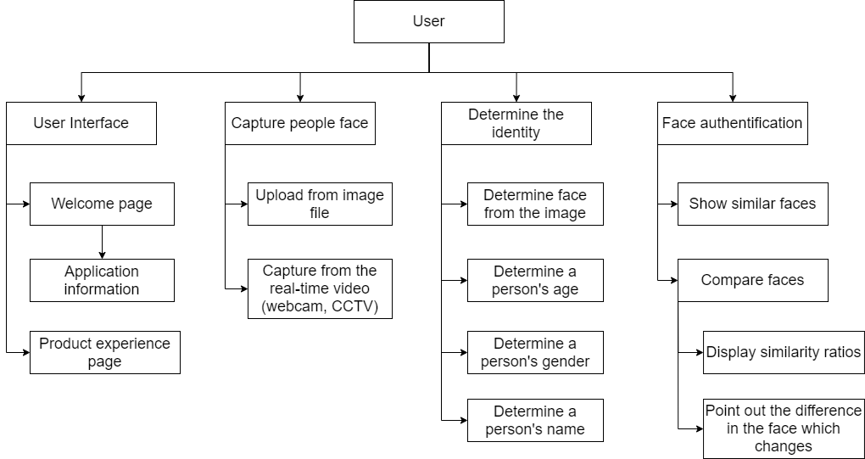

**Figure 1. User module**

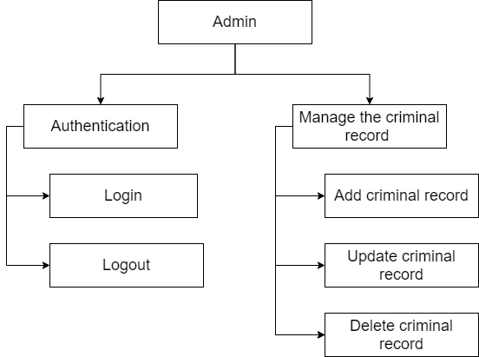

**Figure 2. Admin module**

* 1. **Product Backlog Specification**

Table 1: Product Backlog Specification

|  |  |  |  |  |  |
| --- | --- | --- | --- | --- | --- |
| **ID** | **Theme** | **As a(n)** | **I want to** | **So that** | **Priority** |
| **AUTHENTICATION** | | | | | |
| PB01 | Login | Admin | Access to the system by my account | I can use the system with my role | 2 |
| PB02 | Logout | Admin | Log out system | I can stop using the system. I can log in later when I want to use the system next time | 2 |
| **MANAGE THE CRIMINAL RECORD** | | | | | |
| PB03 | Add criminal record | Admin | Add crime case to a criminal record | I can add a criminal case to the record | 2 |
| PB04 | Update criminal record | Admin | Updates on the crimes in the criminal record | I can update information about the criminal case is available in criminal profiling | 2 |
| PB05 | Delete criminal record | Admin | Delete criminal cases from criminal records | I can remove the criminal case from the record | 3 |
| **USER INTERFACE** | | | | | |
| PB06 | Welcome page | User | Show welcome page | I can see the project information | 2 |
| PB07 | Application information | User | Show application information page | I can see the application information | 3 |
| PB08 | Product experience (PE) page | User | Try face authentication function | I can compare each face was photographed with each face in profile crime data | 1 |
| **CAPTURE PEOPLE FACE** | | | | | |
| PB09 | Upload from image or video file | User | Upload the photo or video from the gallery | I can upload the photo or video from my computer | 1 |
| PB10 | Capture from the real-time video (webcam) | User | Take a photo by using webcam | I can take a photo by using webcam | 1 |
| **DETERMINE THE IDENTITY** | | | | | |
| PB11 | Determine face from image | User | See face has been identified by the square | I can know that face was identified for analysis | 1 |
| PB12 | Determine a person's age | User | See person’s age | I can know the age of person in the image or video | 3 |
| PB13 | Determine a person's gender | User | See person's gender | I can know the gender of person in the image or video | 3 |
| PB14 | Determine a person's name | User | See person's name | I can know the name of person in the image or video | 1 |
| **FACE AUTHENTIFICATION** | | | | | |
| PB15 | Compare faces | User | Compare faces | I can compare the image that is uploaded with the existed face cases | 1 |
| PB16 | Show similar faces | User | See all of the highly similar faces | I can see all of the faces that have highly similar to my face | 1 |
| PB17 | Display similarity ratios | User | See how much the similarities | I can see how much the similarities ratio between faces | 1 |
| PB18 | Point out the difference in the face which changes | User | See the difference in the face which changes | I can see the difference in the face which changes | 1 |

Table 2: Priority impact description

|  |  |  |
| --- | --- | --- |
| **Impact** | | **Description** |
| **1** | Very high | Must have |
| **2** | High | Should have |
| **3** | Medium | Could have |
| **4** | Low | Won’t have |

* 1. **Break down into Sprint Backlog**

Table 3: Break down into Sprint Backlog

|  |  |  |  |
| --- | --- | --- | --- |
| **Sprint** | **Function** | **Started day** | **Due day** |
| **SPRINT 1** | * [Server/Backend] Add necessary packages for Project * [Server/Backend] Create Database Schemas for Project * [Frontend] Setup general layout for the PE page * [Frontend] Create content for the PE page * [Frontend] UI for show uploaded image * [Server/Backend] choose an image from a computer * [Server/Backend] show uploaded image * [Server/Backend] Assemble person image for training (<1000 images) * [Server/Backend] Training image * [Server/Backend] Create API to send the image into the server * [Server/Backend] Create API to return the processed result | 11/3/2021 | 26/3/2021 |
| **SPRINT 2** | * [Frontend] UI for the PE page’s menu bar * [Frontend] UI for the PE page’s footer * [Frontend] UI for open camera (webcam) * [Frontend] UI for showing extracted face from the image * [Frontend] UI for showing picture’s person name after processing * [Server/Backend] Auto extract image from video (webcam) * [Server/Backend] Show captured image from video (webcam) * [Server/Backend] Determine face landmark * [Server/Backend] Extract face from the image * [Server/Backend] Analyze data between faces * [Server/Backend] Compare data of these faces | 27/3/2021 | 20/4/2021 |
| **SPRINT 3** | * [Frontend] Setup general layout for the welcome page * [Frontend] Create menu bar for the welcome page * [Frontend] Create a footer for the welcome page * [Frontend] Create Application information for the welcome page * [Frontend] Show age after the process * [Frontend] Show gender after processing * [Frontend] Show similarity faces using the slideshow * [Frontend] Show the percentage similarity * [Frontend] Show points out the difference * [Server/Backend] Determine a person's age * [Server/Backend] Determine the person's gender * [Server/Backend] Calculate the analyzed data between faces * [Server/Backend] Analyze landmark in-person’s faces * [Server/Backend] Find point out the difference in the face | 21/4/2021 | 14/5/2021 |
| **SPRINT 4** | * [Frontend] UI for Login * [Frontend] UI for Logout * [Frontend] UI for add criminal record * [Frontend] UI for update criminal record * [Frontend] UI for delete criminal record * [Server/Backend] Login * [Server/Backend] Logout * [Server/Backend] Add criminal record * [Server/Backend] Update criminal * [Server/Backend] UI for delete criminal record * [Server/Backend] Find point out the difference in the face | 15/5/2021 | 31/5/2021 |

1. **Constraint**

Table 4: Constraint

|  |  |
| --- | --- |
| **Constraint** | **Condition** |
| **Time** | Project completion time limit in 1620 hours so time to complete project be restricted |
| **People constraint** | 5 people working together to finish the project |
| **The integrated system** | Must be connected to Internet network to operate |
| **Requirements** | According to Product Owner’s Requirements |

1. **Stakeholders and User Description Summary**

Table 5: Stakeholders and User Description Summary

|  |  |  |
| --- | --- | --- |
| **Name** | **Description** | **Role** |
| **Product Owner** | The Person who gives the Requirement | Provide information to develop the system. Make the decision to accept and implement the project, do the unit test |
| **Scrum Master** | This is the stakeholder who leading, manage the system development Team | Controlling, managing, monitoring, make sure the project complete on time, within budget, according to plan and according to requirements |
| **Requirement Analyzer** | This is a stakeholder that works with the Analysts to correctly translate requests or needs into requirements to be used for design | Specifies the details of one or more a part of the system’s functionality by describing one or the aspects of the requirements,  This will include functional and non-functional |
| **Software Architect** | This is a stakeholder that is primary for leading the system development | Responsible for the software architecture, which includes the key technical decisions that constrain the overall design for the project |
| **Coder** | This is a stakeholder that programs the software | Implement the project |

1. **References**

* Smartsheet. *Product Backlog 101: Top Advice from Agile Experts*. [online] Available at: <https://www.smartsheet.com/best-advice-scrum-and-agile-experts-managing-your-product-backlog>
* Cohn, M., *Product Backlog Example*. [online] Mountain Goat Software. Available at: <https://www.mountaingoatsoftware.com/agile/scrum/scrum-tools/product-backlog/example>
* Cohn, M., *Scrum Product Backlog and Agile Product Backlog Prioritization*. [online] Mountain Goat Software. Available at: <https://www.mountaingoatsoftware.com/agile/scrum/scrum-tools/product-backlog>